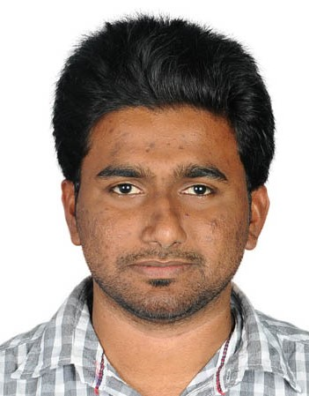**DIXIT K**

**Civil Engineer**

**Mobile no.**: 9880142078 / 8660749380

**Email id**: kdixit109@gmail.com

**Address**: Shrinidhi nilaya Kannaje Laila village & post, Belthangadi, Karnataka.

# **OBJECTIVE**

To succeed and environmental growth and excellence in work which provides me job satisfaction self-development and help me to achieve personal as well as organizational goal.

|  |
| --- |
| **EDUCATION** |

* **B.E in Civil Engineering**, at KLS's Vishwanatha Deshpande Rural Institute of Technology, Haliyal. Visveswarayya Technical University (VTU) Belgaum, Achieving 62% Results in academic year 2010 to 2014.
* **P.U.C** in Sri Manjunatheshvara Pre-University College, Dharwad. Achieving 60% completed on April 2010.
* **S.S.L.C** in Karnataka Education Board’s High school, Dharwad. Achieving 80% completed on April 2008.

|  |
| --- |
| **COMPUTER SKILLS** |

* AutoCAD 2D.
* Microsoft office.

|  |
| --- |
| **PROFESSINAL SUMMARY** |

* Civil Engineer, with **6+ years** of total experience in all aspects of civil projects like execution in site and alteration of 2D civil drawings according to job requirement in AutoCAD.
* Areas of expertise includes construction of Residential and commercial buildings, Water treatment plant, Sewage treatment plant with UGD and samudaya bhavana etc.
* Initiate, manage and if required supervise, design and drafting assignments on projects requirements on time and within budget.
* Experience in making contractor, subcontractor bill, knowledge in BOQ study and RA bills .
* Experience in monitoring the construction of industrial PEB buildings, construction of VDF, erection of steel members, welding work, maintaining quality and safety at construction site.

|  |
| --- |
| **WORK EXPERIENCE IN DETAIL (06 YEARS)** |

**Resource Environmental Engineering and gaurdian constructions LLP, Bangalore.**

Working as Civil Site Engineer Since1st February 2019 to present.

* Construction of STP and adivaasi samudaya bhavana under government sector.
* Modification in foundation and steel detailing drawing.
* Maintaining safety on site through promoting a safety culture.
* Versed with material purchasing and labour management and maintaining quality standards as per requirement of government engineers.

**TATA Motors Ltd, Dharwad**

Worked as Civil project engineer on contract basis from third party consultant Randstad India Pvt ltd CPE department since 1st June 2017 to 31st Sept 2018.

* Worked as client for TATA motors Ltd and main scope of work is quality & safety of ongoing projects.
* Checking of civil drawings and submitting to contractor, creating small structural drawings which is urgently required in plant.
* Performing regular site visits and inspections.
* Ensure that all the works meets the stipulated quality standards.
* Co-ordination with contractor regarding work progress.

**Amar Infra projects, Mangalore**.

Worked as Site Engineer- Civil Since 1st October 2014 to till 30th of December 2016.

* Verify the drawing received in site as per the design drawing.
* Modification in foundation and various RCC/Steel detailing drawings in AutoCAD.
* To produce purchase requisitions, quality checking of materials, which used for construction.
* Monitor and Inspect the roughing-ins of rebar installation and formworks prior for concrete pouring.

|  |  |
| --- | --- |
| **PERSONAL INFORMATION** | |
| * Date of Birth | :13th April 1992. |
| * Nationality | :Indian |
| * Marital Status | :Single |
| * Languages Known | :English, Kannada, Hindi |
| * Passport No * Driving licence | :M4723754  :India Driving Licence of Light Motor Vehicle |
| **DECLARATION** |  |

I hereby declare that all the particulars stated above are true to the best of my knowledge and belief.

**Place**: Belthangadi, Karnataka.

**Date**: 2021

**(DIXITK)**